CSCE 606 Software Engineering, Spring 2021

Team Spongebob : Iteration 0 Project Report

## Team Members

* **Scrum Master**: Hannah Patrick
* **Product Owner**: Nathaniel Raggo
* Mehdi Gorjian
* Farnoosh Shirani Bidabadi
* Jason Spencer
* Alireza Safdari

## Customer Meeting Times

* Dates
  + Initial Meeting: Wednesday, April 7
  + Recurring Meetings: Mondays - April 12, April 19, April 26, May 3
* Time: 5PM CST
* Place: Zoom

## Summary

As part of the State of Texas Assessments of Academic Readiness (STAAR) program, Texas schools are evaluated based upon students’ performances, progressions, and improvements in math, reading, and writing. As a result, schools are interested to predict how students may perform in their next STAAR Test, so they can direct their attention and resources to the students who need more help.

Educational Leadership Research Center (ELRC) at Texas A&M University has worked on a machine learning model which predicts a student’s performance based on the student’s percent score in the previous tests. ELRC wants a website so that the schools and teachers can add student information and obtain predictions on the student’s performance based on the machine learning models. The teachers and schools need to be able to log in and have their data added for the machine learning model for predictions. ELRC desires a website that is easy for teachers and schools to use so that they can login conveniently and upload their students’ data as CSV files. The website would then run the machine learning model and provide the results in an easy to use format for the teachers and schools.

## User Stories & Mockups

● Feature: Log in to website

○ As a teacher

○ I want to log in

○ So that I can access the app under my profile

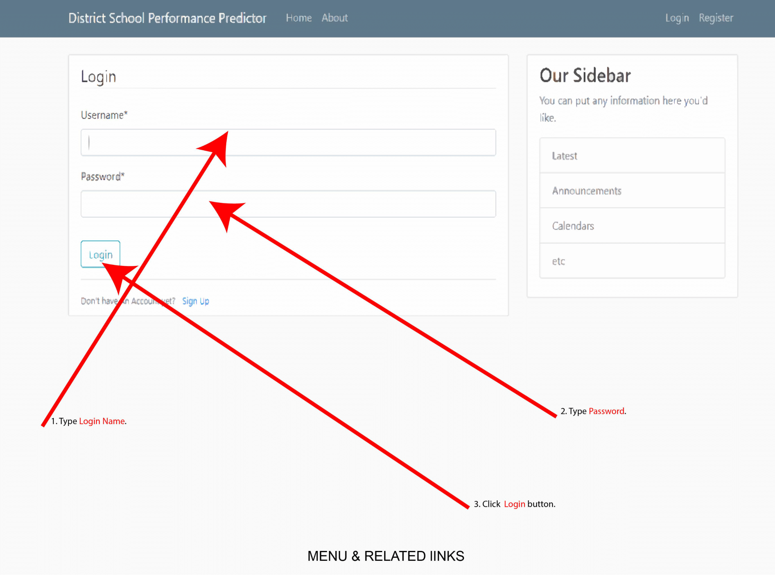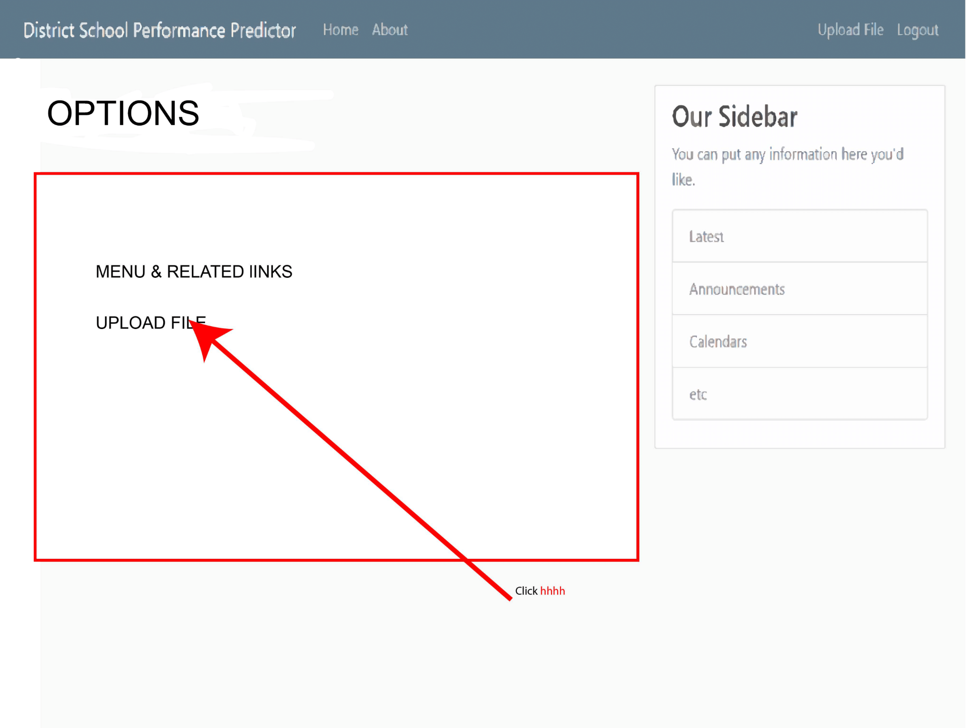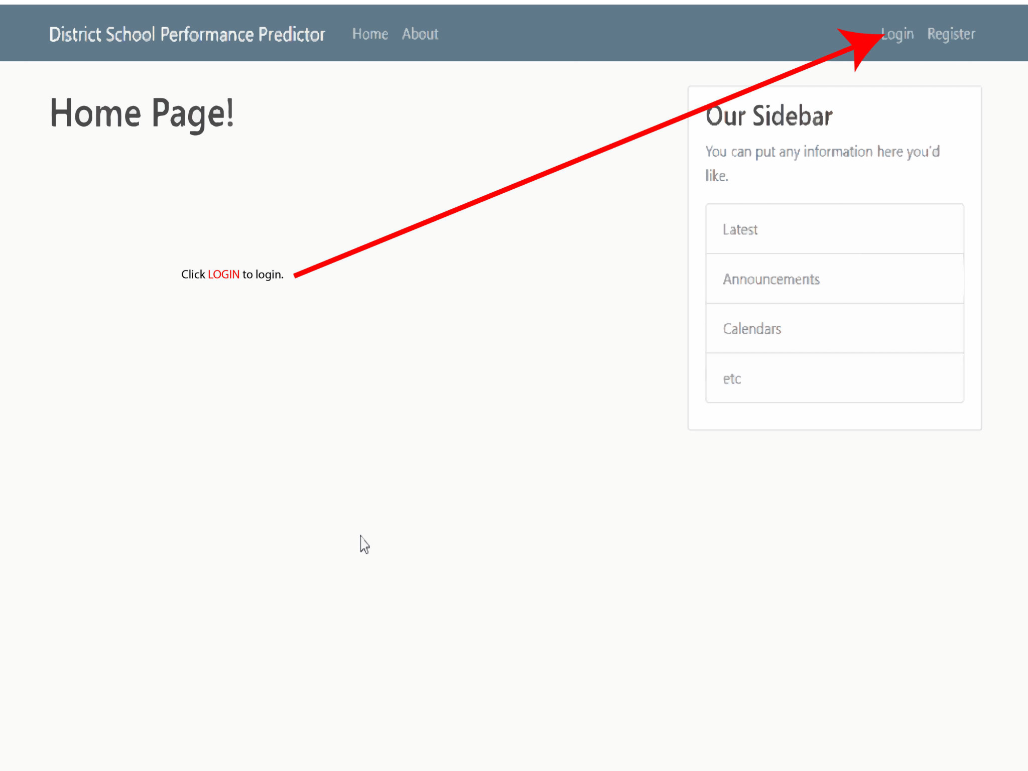

● Feature: Upload a CSV file

○ As a teacher

○ I want to upload a CSV File with Student Data

○ So that I can run the AI prediction

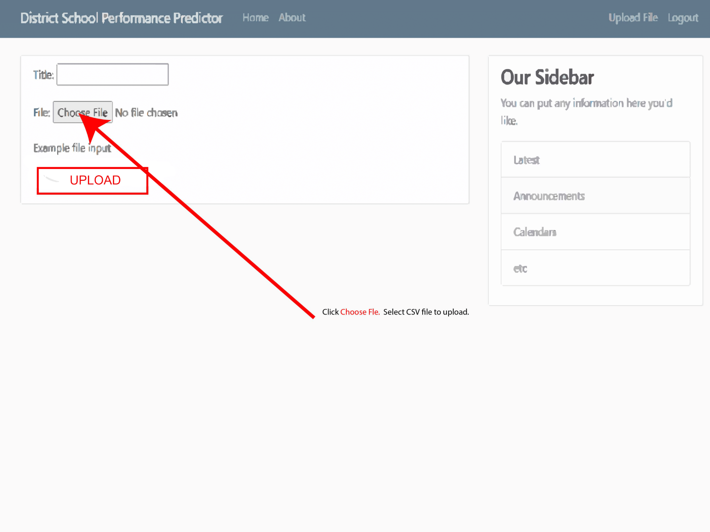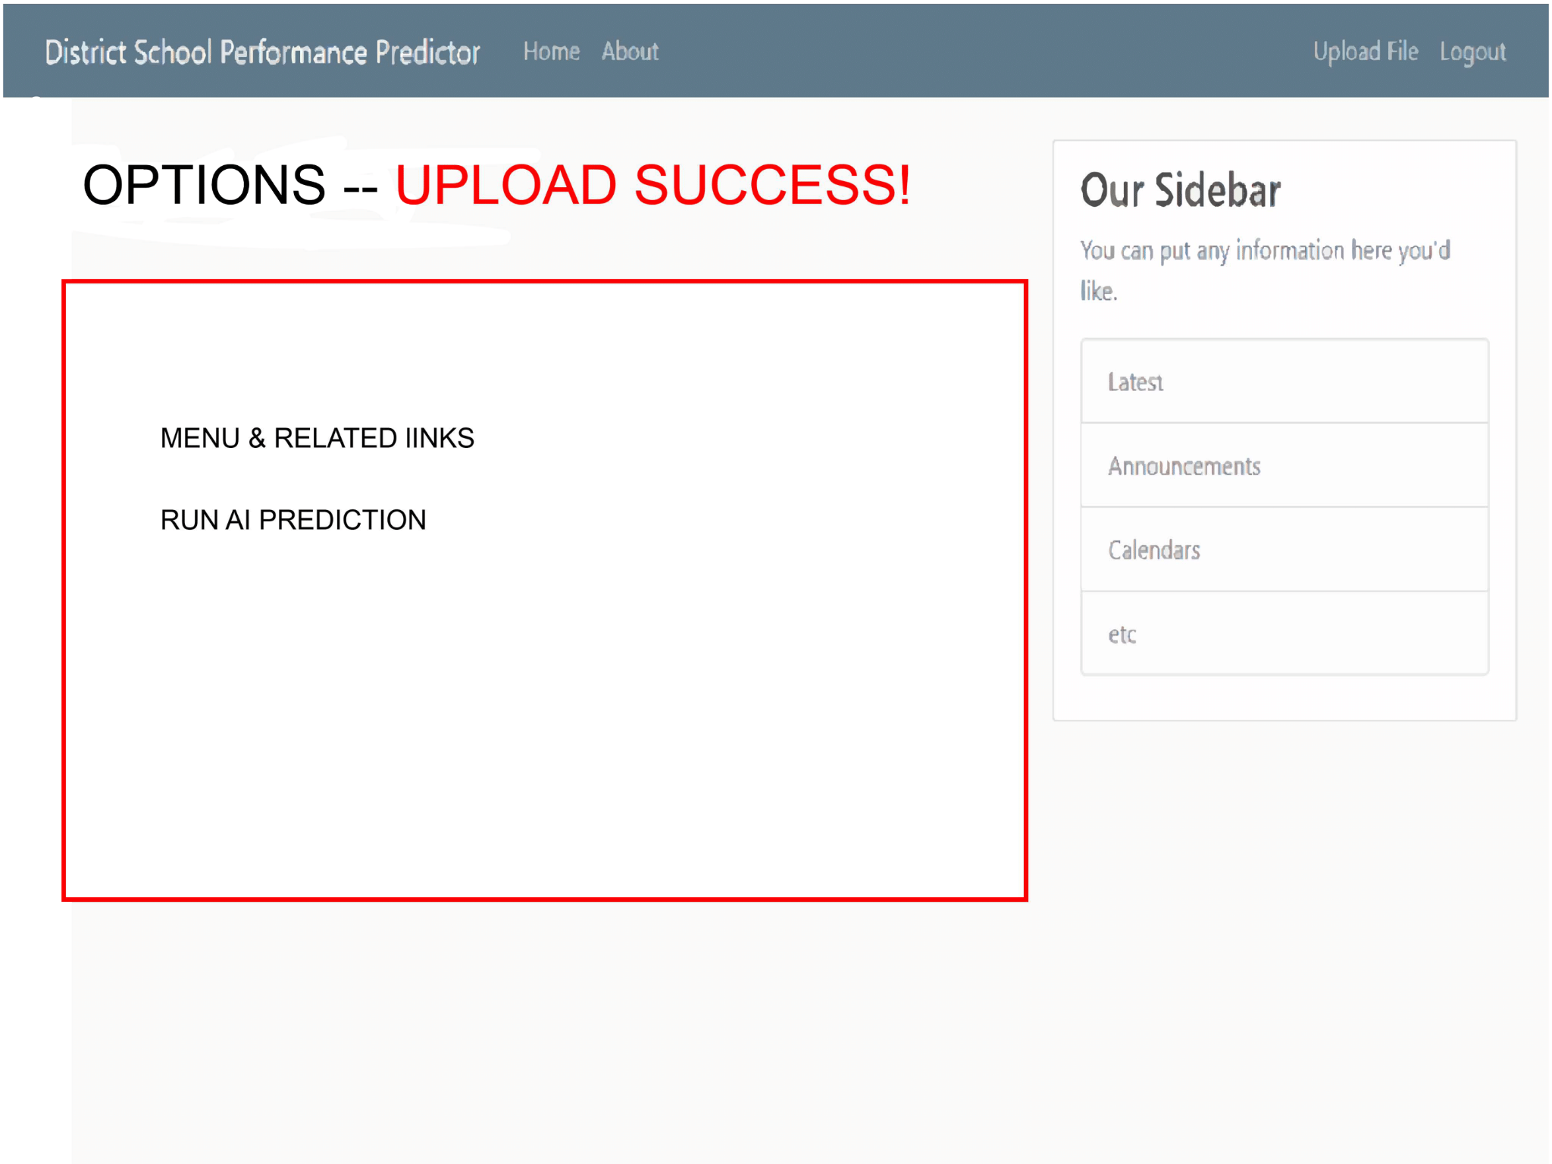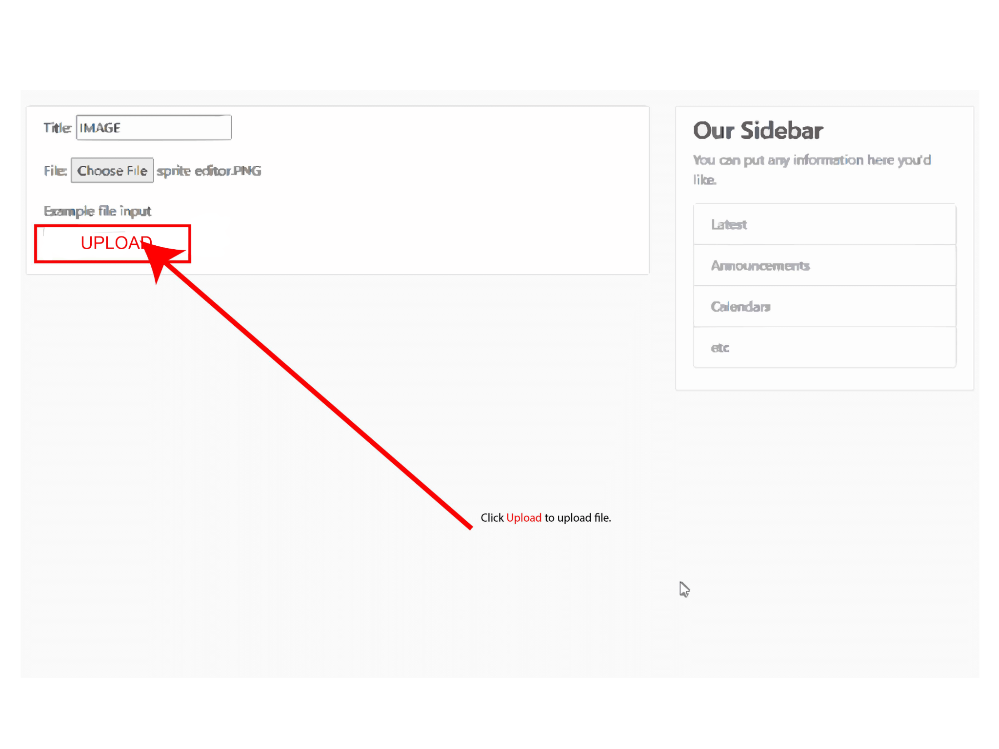

● Feature: Model uses Input Data for Prediction

○ As a teacher

○ I want the trained model to perform the prediction

○ So that I can receive insights into the data

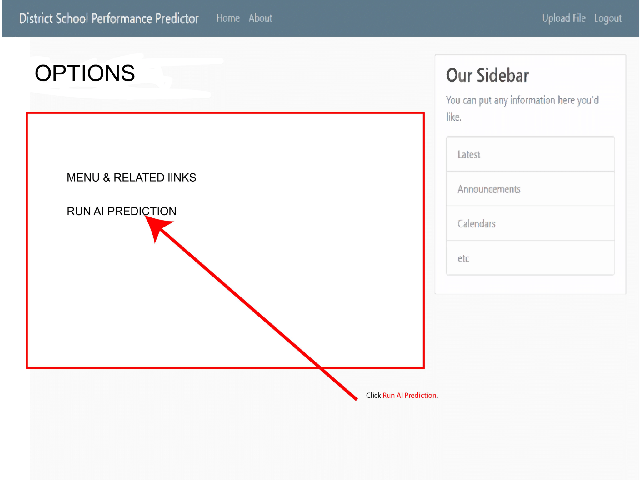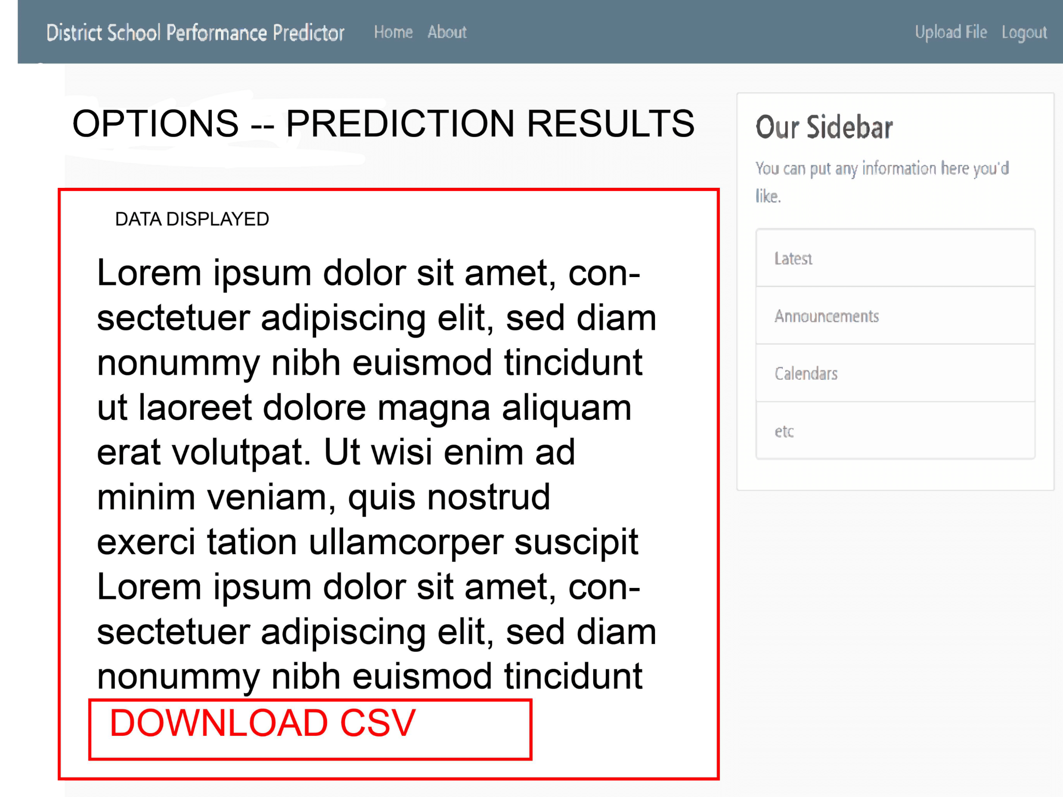

● Feature: Download the prediction result

○ As a teacher

○ I want to be able to download the detailed data of the prediction results in the form of a CSV file

○ So that I can view the results

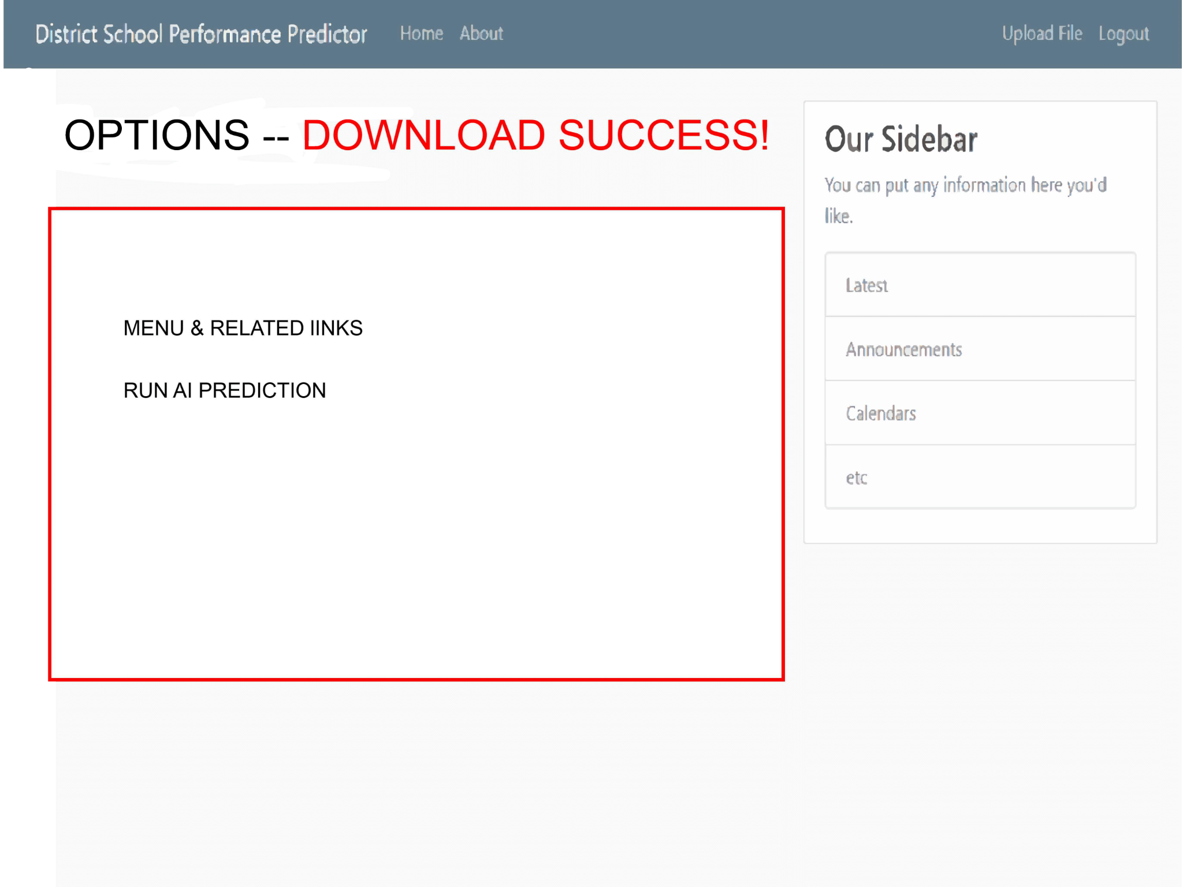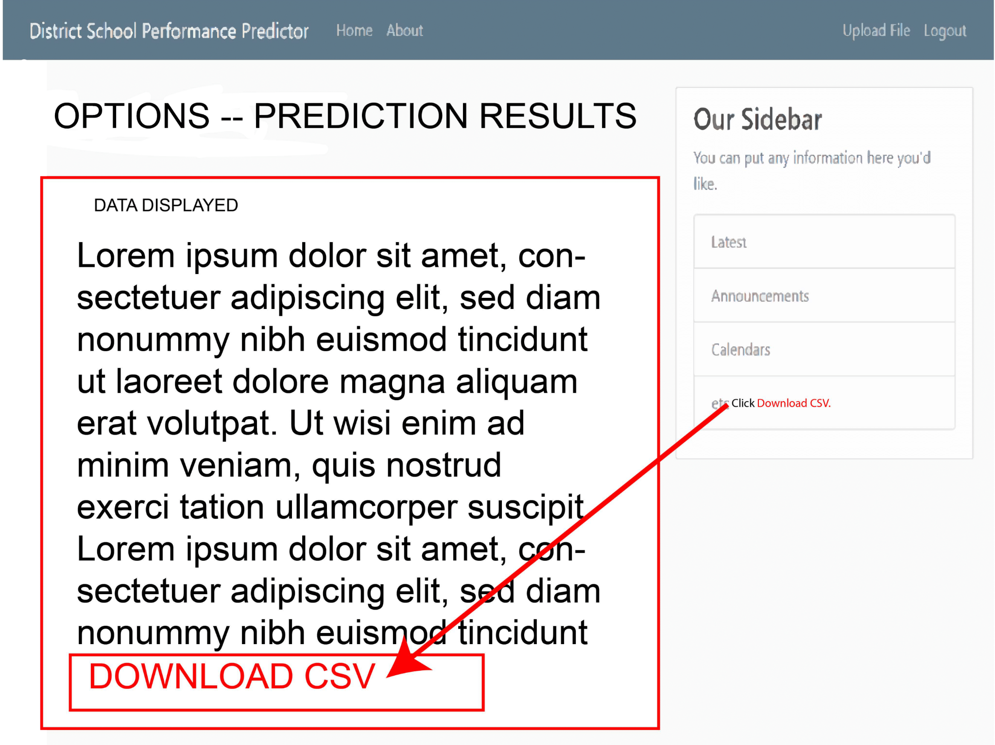

## 

## Legacy Project Elaboration

The legacy project school performance prediction is a tool for teachers that allows them to upload their student’s grades and receive a prediction of their standardized test scores. The calculations are done by a machine learning model written in Jupyter notebooks using Python and its scikit-learn toolkit. The existing user interface was created using Python’s Django, HTML, and CSS. We plan to continue building off of the legacy website and will not be changing the language or frameworks used. Because our course was taught using Ruby and Ruby on Rails, our team will have to spend time learning how to use Python and the Django framework, as well as how to integrate Jupyter notebooks into our web application. In addition, we are required to coordinate with ThinkSmart, the team working on improving the machine learning portion of this legacy project, to ensure our application is compatible with any changes they make to the code.

To get a better understanding of what work was already completed in this legacy project, we pulled the code into our own Github repository, reviewed their iterations files and final project presentation, and deployed the source code to Heroku. We also cloned the Github repository into our own AWS Cloud9 instances to gain a better understanding of the code. As mentioned in the writeup of the previous team, their main focus was the development of a functional machine learning model rather than a website. This is reflected in the minimally implemented user interface, which only consists of a few pages including the login and sign up. Their writeup included future stories for enhancing the website, such as a way to upload a CSV file which we are planning to implement.

However, we need to make revisions to stories completed by the last team. We discovered by looking at the database in our Heroku deployment that the application is not set up to store login credentials. In addition, tests were written for the login and register functionality of the website, but they appear to have not been working. When the code coverage command is run, a long list of errors appear in the output text file. Fixing these tests would allow us to see the correct code coverage and provide us with a baseline for additional tests that need to be written.

In summary, the SAAS application is the generation of analytic data by the machine learning model, and its availability on a user friendly website. We will focus on building out the uncompleted stories from the previous team. These stories develop the existing basic web application in order to provide an interface compatible with the machine learning model improved upon by the ThinkSmart team.

## 

## Grading Approach Request

Beyond the additional consideration that our project is a legacy project coded in Python, HTML, and CSS it should also be recognized that this is a multi-team project. Two separate teams, ThinkSmart and Spongebob, are attempting to simultaneously advance the school performance prediction project with a new user interface, and improvements to the machine learning model’s prediction. Defining specific team goals with the clients and professor has necessitated greater time and effort than anticipated, which subsequently delayed our work by a week. A custom grading approach should be considered explicitly in regard to the coding language utilized in this project, prior incomplete user stories and poor testing coverage, and the corresponding expectation of success in advancing this legacy project. Currently, but subjected to change with more details, our team considers success as the development of the user interface in which a teacher can obtain their personalized machine learning model predictions by inputting their own data. We are not considering the performance of the machine learning model within our own success as team ThinkSmart is overseeing this aspect of the project.

## Project Software Aids Links

* GitHub repository: <https://github.com/hpatrick5/sp21-csce606-group_project>
* Pivotal Tracker: <https://www.pivotaltracker.com/n/projects/2489771>
* Our running instance of the legacy project: [https://sp21-606-school-district-data.herokuapp.com/](https://sp21-606-school-district-data.herokuapp.com/login/)
* Slack : All requested people have been added.
* Project Definition (School District Data): <https://pro-assign.herokuapp.com/projects/58>